A New Method for European Option Pricing
With Two Stocks

Yu-dong Sun ¹ and Yi-min Shi ²

¹Department of Applied Mathematics, Northwestern Polytechnical University,
Xi'an – 710072, Xi'an, China. E-mail: sunyudongxa@163.com

²Department of Applied Mathematics, Northwestern Polytechnical University,
Xi'an – 710072, Xi'an, China. E-mail: ymshi@nwpu.edu.cn

Received; accepted

Abstract. Assume that the stock price obey the stochastic differential equation driven by Brownian motion, European option pricing with two stocks is considered by using stochastic dynamic theory at first time. The density function of stock process is obtained by using Fokker-Planck-Kolmogrov equation. Then, the price explicit expression of the European option is given. It provides a new method for European option pricing.

Keywords: European option pricing; stochastic dynamic theory; Fokker-Planck-Kolmogrov equation

AMS Mathematics Subject Classification (2010):

1. Introduction
The break-through in option valuation theory started with the publication of two seminal papers [2]. In the papers the authors introduced a continuous time model of a complete friction-free market where the price of a stock follows a geometric Brownian motion. They presented a self-financing, dynamic trading strategy consisting of a riskless security and a risky stock, which replicates the payoff of an option. Then they argued that the absence of arbitrage dictates that the option price be equal to the cost of setting up the replicating portfolio. For details about this method to study option pricing [3,4,5,8]. In [6], Bladt and Rydberg introduced a new method of option pricing. Using physical probability measure of price process and the principle of fair premium, they deal with the problems of option pricing under the unbalance, arbitrage existing and incomplete circumstance, and transform option pricing into a problem of equivalent and fair insurance premium.
In contrast to these references, this text aims to present the new method of option pricing by using Fokker-Planck equation. The paper is organized as follows. In section 2, we give brief review of Fokker-Planck equation. In section3, under the assumption that the stock price obeys Black-Schole model, we present the density function of stock price at every time by using Fokker-Planck equation. In section4, the option pricing base on this stock is discussed. Section 5 contains conclusions.

2. Some mathematical tools
Let’s consider a simple example. Later, we’ll use the result of this example to provides a new method for European claim pricing. Consider a dynamic system driven by fractional noise
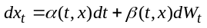 (1)
where x₀ is constant, 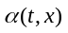and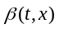are functions dependent on t and x. 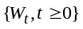is the standard Brownian motion under the complete probability space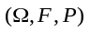. We endow the probability space with the filtration 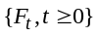 generated by. So that, we get the following important.

Lemma 2.1 (FPK equation) The solution for the density function p(t,x) of Eq(1) can then be written
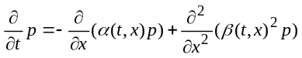. (2)
where the density function p(t,x) satisfied initialization conditions of dynamic system (1)
P(0,x) is deterministic.
And, it also satisfied infinite boundary
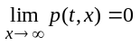.
Its demonstration see Risken(1989).

3. The Model
Consider a fractional Black-Scholes market model with a money market account and two stocks. We assume that the two stocks price S1(t), S2(t) satisfy the stochastic differential equations
. (3)
Where, return rate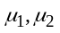 dividend rate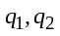 volatility rate 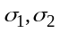and mean value recovery rate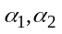are constant. 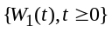andare the standard Brownian motion under the same complete probability space, respectively. Denote the natural-field flow by which is generated by and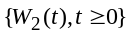.
We also assume that a money market account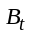, with dynamics
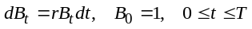. (4)
so that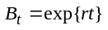, where the interest rate r is constant. We introduce an new probability measure Q such that
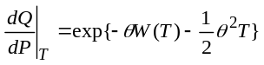,
where
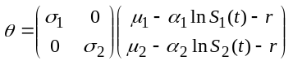,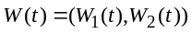, 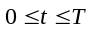.
4. Option Pricing
In what follows we introduce some relevant derivatives of two stocks, and show how to obtain the formulae for the value of these derivatives. Let
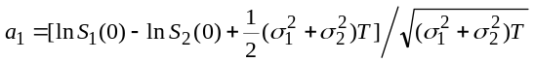,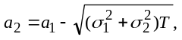,
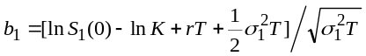,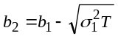,
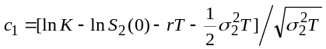,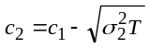,
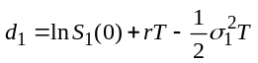, 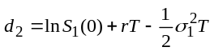.
Lemma 4.1. The price at time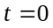of a bounded F₀−measurable claim 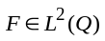, whose derivative of the two stocks S₁(T), S₂(T) , is given by
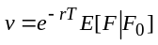.
Consider the derivative with the pay off function
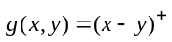,
called the Swap Option to exchange a stock S₂(T) for another stock S₁(T) .

Theorem 4.1. The value of the Swap Option, which exchange a stock S₂(T) for another stock S₁(T) at time 0 is given by
.
Proof. By the Theorem 3.2, we have
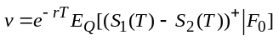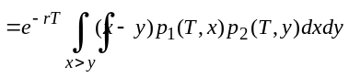
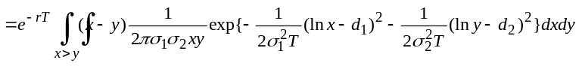
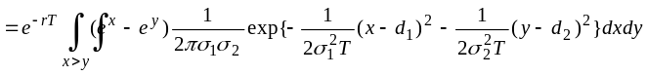
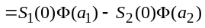 □
Corollary 4.1. The value of the European Call Option of the stock S₁(T) with exercise price K, at time t=0, is given by
.
Proof. Let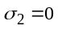,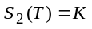, In theorem 4.1, we have
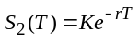,a₁=b₁, a₂=b₂.

Acknowledgements
This work is supported by the National Natural Science Foundation of China (No. 70471057) and the Natural Science Foundation of Education Department of Shaanxi Province (No. 03JK065).

REFERENCES

- T.H. Byers and M.S. Waterman, Determining all optimal and near-optimal solutions when solving shortest path problems by dynamic programming, Operations Research, 32 (1984) 1381-1384.
- W.M. Carlyle and R.K. Wood, Near-shortest and K-shortest simple paths, Networks, 46(2) (2005) 98-109.
- B.V. Cherkassky, A.V. Goldberg, and T. Radzik, Shortest path algorithms: Theory and experimental evaluation, Proceedings of the Fifth Annual ACM-SIAM Symposium on Discrete Algorithms, Arlington, Virgina, 23–25 January 2005, 516–525.
- D. Dubois and H. Prade, Fuzzy Sets and Systems: Theory and Applications, Academic Press, New York, 1980.
- S.M.A. Nayeem and M. Pal, Shortest path problem on a network with imprecise edge weight, Fuzzy Optimization and Decision Making, 4 (2005) 293-312.

